
PATUAKHALI SCIENCE AND TECHNOLOGY UNIVERSITY
COURSE CODE CIT-112

SUBMITTED TO:

Md. Mahbubur Rahman

Department of Computer Science and Information Technology
Faculty of Computer Science and Engineering

SUBMITTED BY:
Md. Sharafat Karim
ID: 2102024,
Registration No: 10151
Faculty of Computer Science and Engineering

Assignment: 07
Table of Contents
1 Write a program, which reads your name from the keyboard and outputs a list of ASCII codes, which represent your name. 4
2 Write a program to do string processing 5
5
3 Write a program to extract a portion of a character string and print the extracted string. Assume that m characters are extracted, starting with the nth character. 7
4 Write a program which will read a text and count all occurrences of a particular word. 9
5 Write a program which will read a string and rewrite it in the alphabetical order. For example, the word STRING should be written as GINRST. 11
6 Write a program to replace a particular word by another word in a given string. For example, the word “PASCAL” should be replaced by “C” in the text “It is good to program in PASCAL language.” 13
8 Write a program that reads a string from the keyboard and determines whether the string is a palindrome or not. (A string is a palindrome if it can be read from left and right with the same meaning. For example, Madam and Anna are palindrome strings. Ignore capitalization). 16
9 Write program that reads the cost of an item in the form RRRR.PP (Where RRRR denotes Rupees and PP denotes Paise) and converts the value to a string of words that expresses the numeric value in words. For example, if we input 125.75, the output should be “ONE HUNDRED TWENTY FIVE AND PAISE SEVENTY FIVE”. 18
10 Develop a program that will read and store the details of a list of students in the format 22
11 Write a program to read two strings and compare them using the function strncmp( ) and print a message that the first string is equal, less, or greater than the second one. 26
12 Write a program to read a line of text from the keyboard and print out the number of occurrences of a given substring using the function strstr ( ). 28
13 Write a program that will copy m consecutive characters from a string s1 beginning at position n into another string s2. 30
14 Write a program to create a directory of students with roll numbers. The program should display the roll number for a specified name and vice-versa. 32
15 Given a string make a pyramid out of it 35
16 Write a C program to compare two strings without using any string function. 37
17 Write a C program to find the largest and smallest sized word in a string. 39
18 Write a C program to replace all the white spaces in a string with double white spaces. 42
19 Write a C program to enter multiple strings and display them in lexicographical order. 44
20 Write a C program to concatenate two strings without using any string function. 46

1 Write a program, which reads your name from the keyboard and outputs a list of ASCII codes, which represent your name.

#include<stdio.h>
int main()
{
char name[32];
scanf("%[^\n]", name);
for (int i=0; name[i] != '\0'; i++)
{
printf("%c - %d\n", name[i], name[i]);
}
}

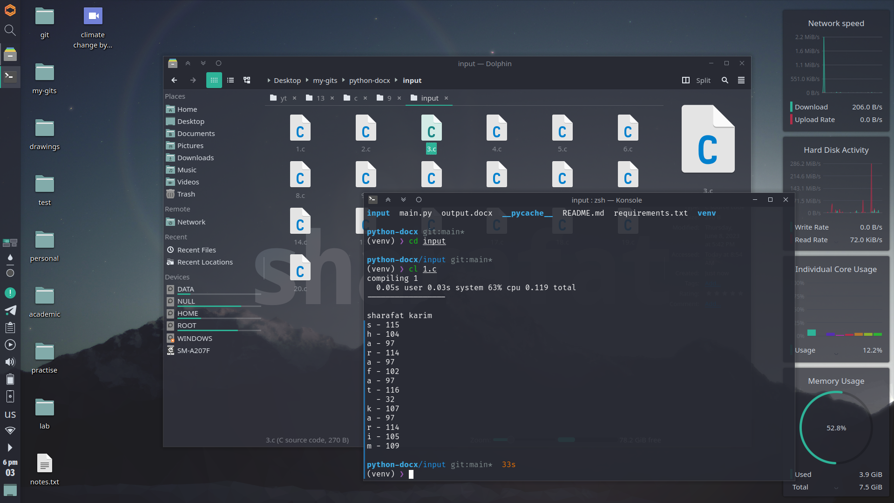

2 Write a program to do string processing

#include <stdio.h>
#include <string.h>
int main()
{
char answer[64];
int attemp = 3;
while (attemp--)
{
printf("Who is the inventor of C? \n");
scanf(" %[^\n]", answer);
if (strcmp(answer, "Dennis Ritchie") == 0)
{
printf("Good\n");
break;
}
else
{
printf("try again\nCorrect answer: Dennis Ritchie\n");
}
}
}
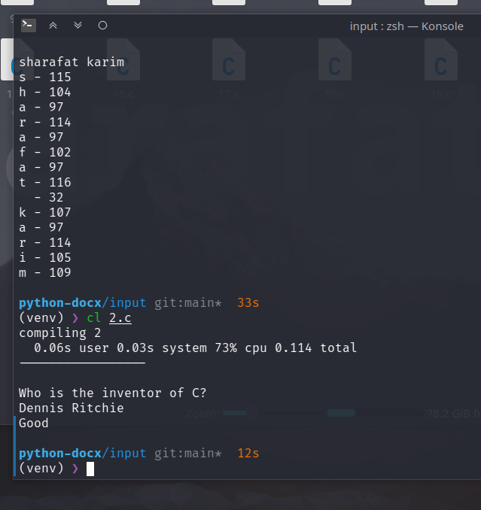

3 Write a program to extract a portion of a character string and print the extracted string. Assume that m characters are extracted, starting with the nth character.

#include<stdio.h>
#define init 2
#define end 6
int main()
{
char string[32], modified_string[32];
scanf("%[^\n]", string);
for (int i= init-1; i < end; i++)
{
modified_string[i-init+1] = string[i];
}
printf("%s\n", modified_string);
}
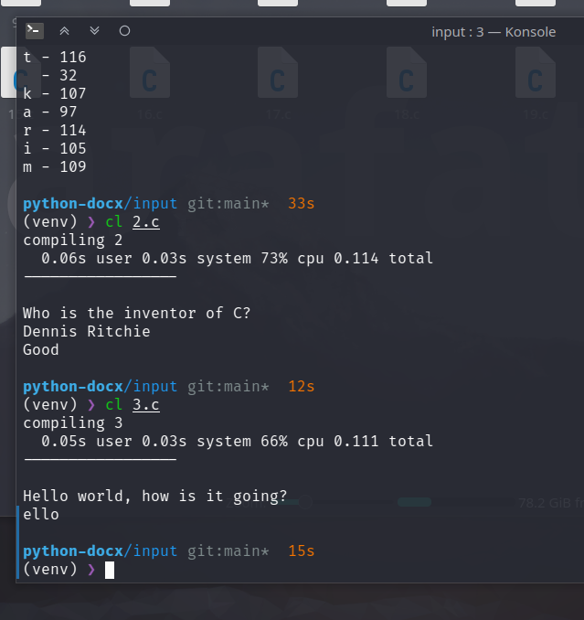

4 Write a program which will read a text and count all occurrences of a particular word.

#include<stdio.h>
#define occurance 'a'
int main()
{
char string[32];
scanf("%[^\n]", string);
int i=0, count = 0;
while (string[i] != '\0')
{
if (string[i++] == occurance)
{
count++;
}
}
printf("Total occurance of %c = %d\n", occurance, count);
}
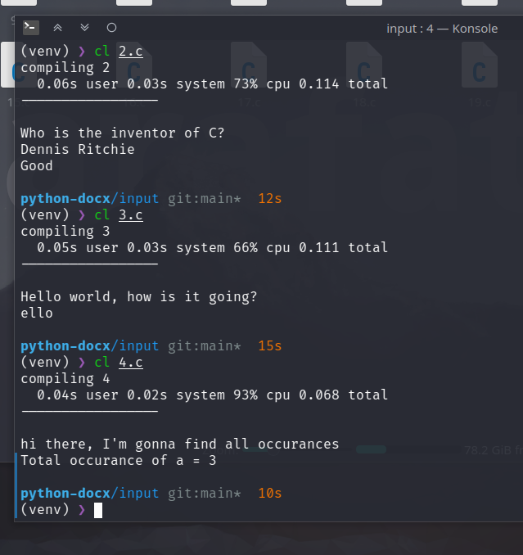

5 Write a program which will read a string and rewrite it in the alphabetical order. For example, the word STRING should be written as GINRST.

#include<stdio.h>
#include<string.h>
int main()
{
char name[32];
scanf("%[^\n]", name);
int size = strlen(name);
int i, j;
for (i=0; i < size; i++)
{
for (j=0; j < size-i-1; j++)
{
if (name[j] > name[j+1])
{
char temp = name[j];
name[j] = name[j+1];
name[j+1] = temp;
}
}
}
printf("%s\n", name);
}
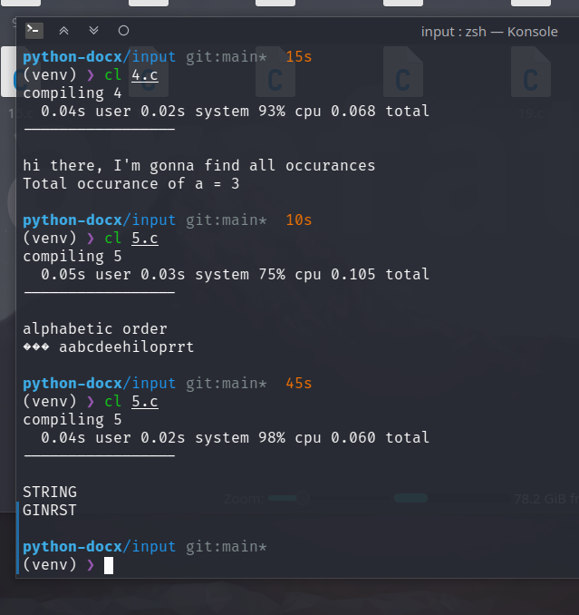

6 Write a program to replace a particular word by another word in a given string. For example, the word “PASCAL” should be replaced by “C” in the text “It is good to program in PASCAL language.”

#include<stdio.h>
#include<string.h>
int main()
{
char str[64], modified_str[64];
printf("Enter the string: ");
scanf("%[^\n]", str);
char replace_from[16];
printf("Enter the string to replace: ");
scanf("%s", replace_from);
char replace_with[16];
printf("Enter the string to replace with: ");
scanf("%s", replace_with);
int size = strlen(str);
printf("-----------------------\n");
int i, temp;
for (i=0, temp=0; i<size; i++)
{
if (str[i] == replace_from[0])
{
for (int j=0; j<strlen(replace_from);j++)
{
if (str[i-j] != replace_from[j])
break;
else
{
for (int k=0; k<strlen(replace_with); k++)
{
modified_str[temp++] = replace_with[k];
i += strlen(replace_from);
}
}
}
}
modified_str[temp++] = str[i];
}
modified_str[temp] = '\0';
printf("%s\n", str);
printf("%s", modified_str);
}
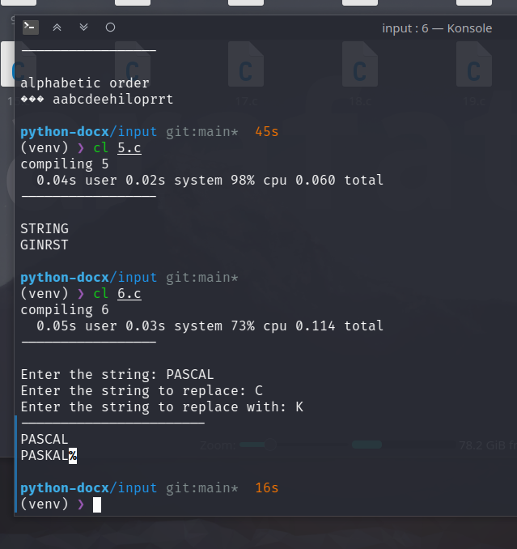

8 Write a program that reads a string from the keyboard and determines whether the string is a palindrome or not. (A string is a palindrome if it can be read from left and right with the same meaning. For example, Madam and Anna are palindrome strings. Ignore capitalization).

#include<stdio.h>
#include<string.h>
int main()
{
char string[64];
scanf("%[^\n]", string);
int size = strlen(string);
for (int i=0, j=size-1; i < size/2; i++, j--)
{
if (string[i] != string[j])
{
printf("Not a palindrome");
return 0;
}
}
printf("A palindrome");
return 0;
}
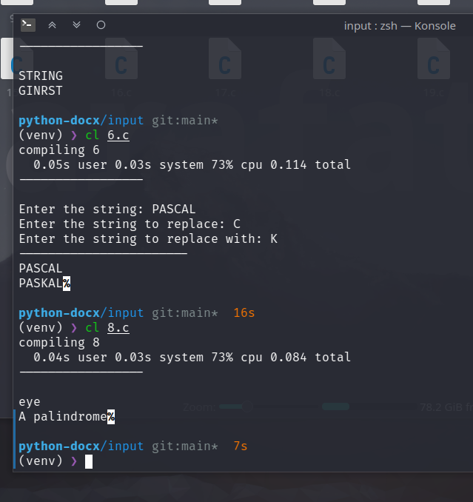

9 Write program that reads the cost of an item in the form RRRR.PP (Where RRRR denotes Rupees and PP denotes Paise) and converts the value to a string of words that expresses the numeric value in words. For example, if we input 125.75, the output should be “ONE HUNDRED TWENTY FIVE AND PAISE SEVENTY FIVE”.

// Write program that reads the cost of an item in the form RRRR.PP (Where RRRR denotes Rupees and PP denotes Paise) and converts the value to a string of words that expresses the numeric value in words.
// For example, if we input 125.75, the output should be “ONE HUNDRED TWENTY FIVE AND PAISE SEVENTY FIVE”.
#include<stdio.h>
#include<string.h>
char* get_first_nine_number(int num)
{
switch(num)
{
case 0: return "ZERO";
case 1: return "ONE";
case 2: return "TWO";
case 3: return "THREE";
case 4: return "FOUR";
case 5: return "FIVE";
case 6: return "SIX";
case 7: return "SEVEN";
case 8: return "EIGHT";
case 9: return "NINE";
case 10: return "TEN";
case 11: return "ELEVEN";
case 12: return "TWELVE";
case 13: return "THIRTEEN";
case 14: return "FOURTEEN";
case 15: return "FIFTEEN";
case 16: return "SIXTEEN";
case 17: return "SEVENTEEN";
case 18: return "EIGHTEEN";
case 19: return "NINETEEN";
case 20: return "TWENTY";
case 30: return "THIRTY";
case 40: return "FOURTY";
case 50: return "FIFTY";
case 60: return "SIXTY";
case 70: return "SEVENTY";
case 80: return "EIGHTY";
case 90: return "NINETY";
}
}
char* get_number(int num)
{
char string[50];
if (num <= 20 )
return get_first_nine_number(num);
else
{
strcpy(string, "");
strcat(string, get_first_nine_number((num/10)*10));
strcat(string, " ");
strcat(string, get_first_nine_number(num%10));
char *string2 = string;
return(string2);
}
}
int main()
{
float cost;
printf("Enter the cost: ");
scanf("%f", &cost);
int rupees = (int)cost;
int paise = (int)((cost - rupees) * 100);
char rupees_string[100];
strcpy(rupees_string, "");
if ( rupees >= 1000 )
{
int thousands = rupees / 1000;
strcat(strcat(rupees_string, get_number(thousands)), " THOUSAND ");
rupees = rupees % 1000;
}
if ( rupees >= 100 )
{
int hundreds = rupees / 100;
strcat(strcat(rupees_string, get_number(hundreds)), " HUNDRED ");
rupees = rupees % 100;
}
if ( rupees >= 1 )
{
strcat(strcat(rupees_string, get_number(rupees)), " AND PAISE ");
}
if ( paise >= 1 )
{
strcat(rupees_string, get_number(paise));
}
printf("%s", rupees_string);
printf("\n%d", rupees);
}
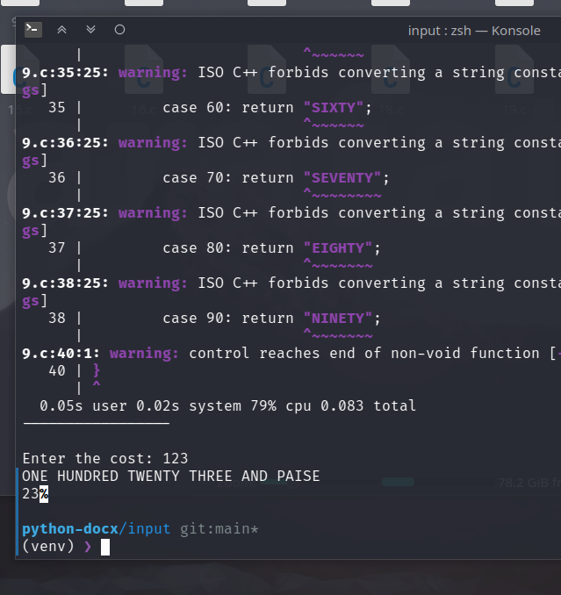

10 Develop a program that will read and store the details of a list of students in the format

#include<stdio.h>
struct student
{
int roll_no;
char name[50];
int marks;
};
void sorting_array_with_index(int main[], int sorted_index[])
{
int n = sizeof(main)/sizeof(main[0]);
for (int i = 0; i < n; i++)
{
sorted_index[i] = i;
}
for (int i = 0; i < n; i++)
{
for (int j = i; j < n-1; j++)
{
if (main[sorted_index[j]] > main[sorted_index[j+1]])
{
int temp = sorted_index[j];
sorted_index[j] = sorted_index[j+1];
sorted_index[j+1] = temp;
}
}
}
}
int main()
{
int n;
printf("Enter the number of students: ");
scanf("%d", &n);
struct student students[n];
for (int i = 0; i < n; i++)
{
printf("Enter the roll number of student %d: ", i+1);
scanf("%d", &students[i].roll_no);
printf("Enter the name of student %d: ", i+1);
scanf("%s", students[i].name);
printf("Enter the marks of student %d: ", i+1);
scanf("%d", &students[i].marks);
}
printf("\n\n");
printf("Table of students (alphabetic list)\n");
printf("Roll No\t\tName\t\tMarks\n");
for (int i = 0; i < n; i++)
{
printf("%d\t\t%s\t\t%d\n", students[i].roll_no, students[i].name, students[i].marks);
}
printf("\n\n");
printf("Table of students (sorted on roll numbers)\n");
int sorted_roll_no_index[n];
int students_roll_no[n];
for (int i = 0; i < n; i++)
{
students_roll_no[i] = students[i].roll_no;
}
sorting_array_with_index(students_roll_no, sorted_roll_no_index);
printf("Roll No\t\tName\t\tMarks\n");
for (int i = 0; i < n; i++)
{
printf("%d\t\t%s\t\t%d\n", students[sorted_roll_no_index[i]].roll_no, students[sorted_roll_no_index[i]].name, students[sorted_roll_no_index[i]].marks);
}
printf("\n\n");
printf("Table of students (sorted on marks)\n");
int sorted_marks_index[n];
int students_marks[n];
for (int i = 0; i < n; i++)
{
students_marks[i] = students[i].marks;
}
sorting_array_with_index(students_marks, sorted_marks_index);
printf("Roll No\t\tName\t\tMarks\n");
for (int i = 0; i < n; i++)
{
printf("%d\t\t%s\t\t%d\n", students[sorted_marks_index[i]].roll_no, students[sorted_marks_index[i]].name, students[sorted_marks_index[i]].marks);
}
printf("\n\n");
return 0;
}
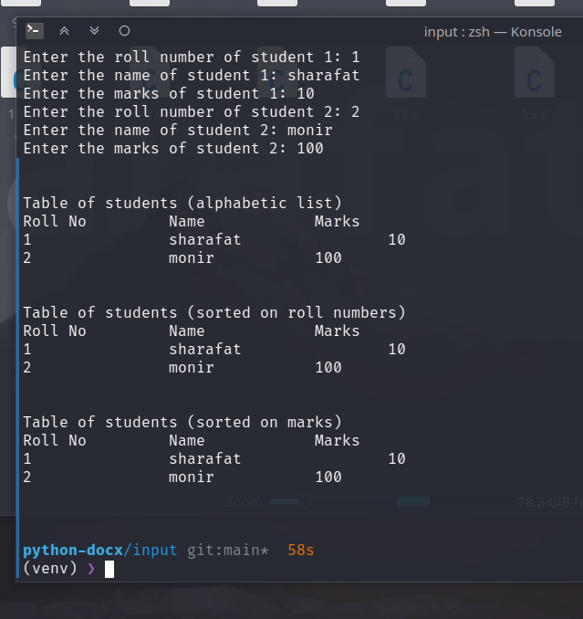

11 Write a program to read two strings and compare them using the function strncmp( ) and print a message that the first string is equal, less, or greater than the second one.

#include<stdio.h>
#include<string.h>
int main()
{
char str1[100], str2[100];
printf("Enter the first string: ");
scanf("%s", str1);
printf("Enter the second string: ");
scanf("%s", str2);
int result = strncmp(str1, str2, 100);
if (result == 0)
{
printf("The first string is equal to the second one.\n");
}
else if (result < 0)
{
printf("The first string is less than the second one.\n");
}
else
{
printf("The first string is greater than the second one.\n");
}
}
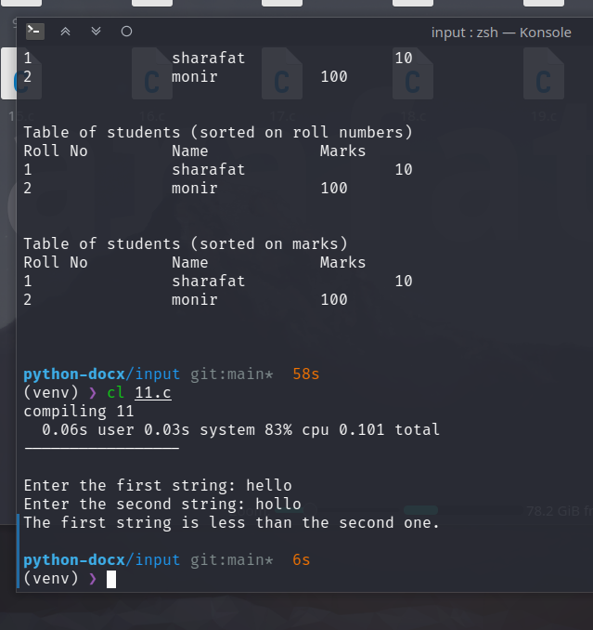

12 Write a program to read a line of text from the keyboard and print out the number of occurrences of a given substring using the function strstr ( ).

#include <stdio.h>
#include <string.h>
int main()
{
char str[100], substr[100];
printf("Enter the string: ");
scanf("%[^\n]%*c", str);
printf("Enter the substring: ");
scanf("%[^\n]%*c", substr);
int count = 0;
char *ptr = strstr(str, substr);
printf("%s\n", ptr+1);
while (ptr != NULL)
{
count++;
ptr = strstr(ptr+1, substr);
}
printf("The substring %s occurs %d times in the string %s.\n", substr, count, str);
}
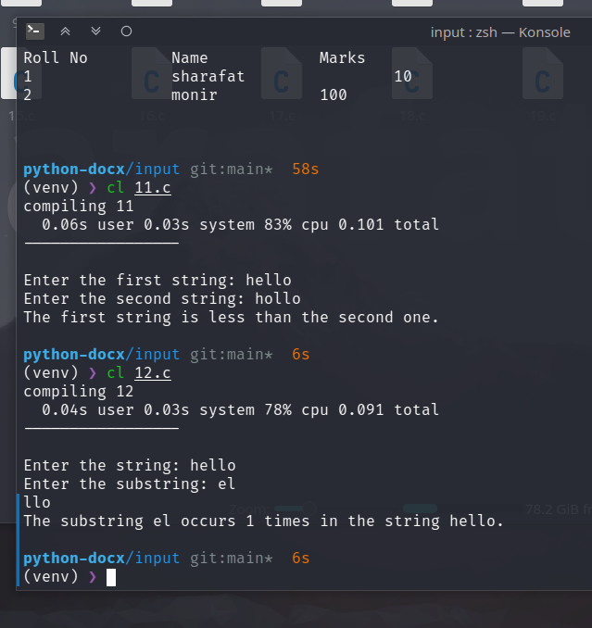

13 Write a program that will copy m consecutive characters from a string s1 beginning at position n into another string s2.
#include<stdio.h>
#include<string.h>
int main()
{
char s1[100], s2[100];
int m, n;
printf("Enter the string: ");
scanf("%[^\n]%*c", s1);
printf("Enter the new string: ");
scanf("%[^\n]%*c", s2);
printf("Enter the value of m: ");
scanf("%d", &m);
printf("Enter the value of n: ");
scanf("%d", &n);
strncpy(s2+n, s1, m);
printf("The string s2 is: %s\n", s2);
}
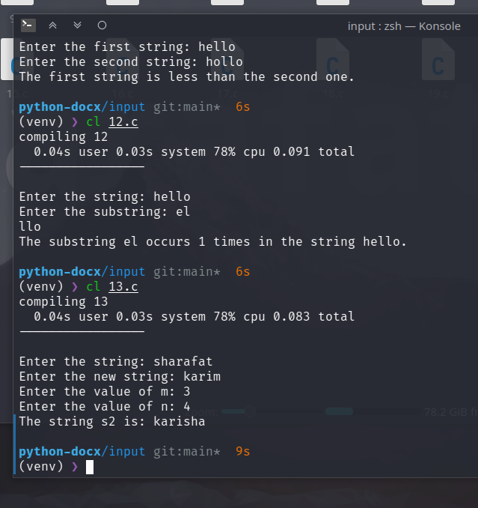

14 Write a program to create a directory of students with roll numbers. The program should display the roll number for a specified name and vice-versa.

#include <stdio.h>
#include <string.h>
#include <stdlib.h>
struct student
{
int roll_no;
char name[50];
};
int main()
{
struct student students[100];
int n;
printf("Enter the number of students: ");
scanf("%d", &n);
for (int i = 0; i < n; i++)
{
printf("Enter the roll number of student %d: ", i+1);
scanf("%d", &students[i].roll_no);
printf("Enter the name of student %d: ", i+1);
scanf("%s", students[i].name);
}
printf("\n\n");
printf("Type student name or roll number to search: \n");
char search[50];
scanf("%s", search);
int found = 0;
for (int i = 0; i < n; i++)
{
if (students[i].roll_no == atoi(search) || strcmp(students[i].name, search) == 0)
{
printf("Roll No: %d\n", students[i].roll_no);
printf("Name: %s\n", students[i].name);
found = 1;
break;
}
}
}

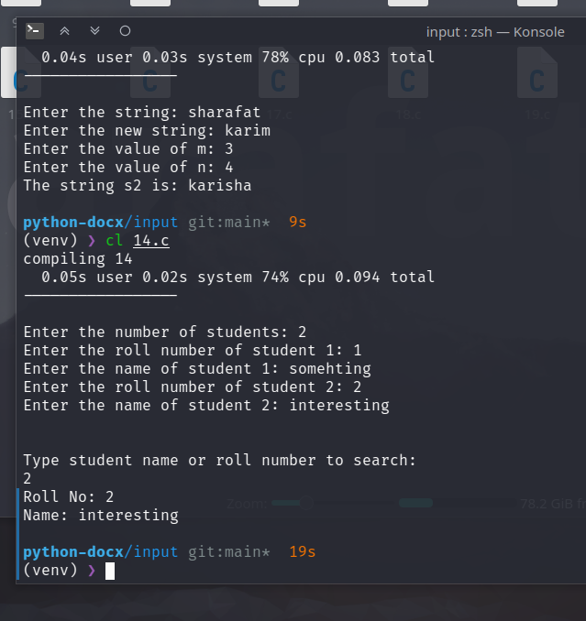

15 Given a string make a pyramid out of it
// Given a string
// ```
// char str [ ] = “123456789” ;
// ```
// Write a program that displays the following:
// ```
// 1
// 2 3 2
// 3 4 5 4 3
// 4 5 6 7 6 5 4
// 5 6 7 8 9 8 7 6 5
// ```
#include <stdio.h>
int main()
{
char str[] = "123456789";
int n = 5;
for (int i = 0; i < n; i++)
{
for (int j = n-i; j > 0; j--)
{
printf(" ");
}
for (int j = i+1; j < 2*i+2; j++)
{
printf("%c ", str[j-1]);
}
for (int j = 2*i; j > i; j--)
{
printf("%c ", str[j-1]);
}
printf("\n");
}
}
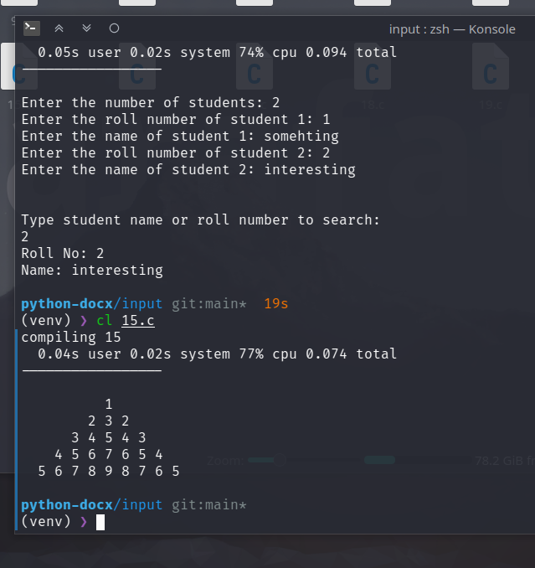

16 Write a C program to compare two strings without using any string function.

// Write a C program to compare two strings without using any string function.
#include <stdio.h>
int main()
{
char str1[100], str2[100];
printf("Enter the first string: ");
scanf("%[^\n]%*c", str1);
printf("Enter the second string: ");
scanf("%[^\n]%*c", str2);
int i = 0;
while (str1[i] != '\0' && str2[i] != '\0')
{
if (str1[i] != str2[i])
{
printf("The strings are not equal.\n");
return 0;
}
i++;
}
if (str1[i] == '\0' && str2[i] == '\0')
{
printf("The strings are equal.\n");
}
else
{
printf("The strings are not equal.\n");
}
}
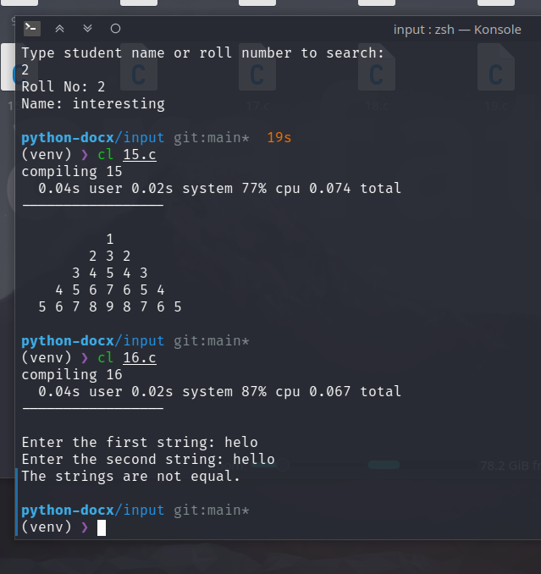

17 Write a C program to find the largest and smallest sized word in a string.

// Write a C program to find the largest and smallest sized word in a string.
#include <stdio.h>
int main()
{
char str[100];
printf("Enter the string: ");
scanf("%[^\n]%*c", str);
int i = 0;
int min = 100, max = 0;
int min_index = 0, max_index = 0;
while (str[i] != '\0')
{
int count = 0;
while (str[i] != ' ' && str[i] != '\0')
{
count++;
i++;
}
if (count < min)
{
min = count;
min_index = i - count;
}
if (count > max)
{
max = count;
max_index = i - count;
}
if (str[i] == '\0')
{
break;
}
i++;
}
printf("The smallest word is: ");
for (int j = min_index; j < min_index + min; j++)
{
printf("%c", str[j]);
}
printf("\n");
printf("The largest word is: ");
for (int j = max_index; j < max_index + max; j++)
{
printf("%c", str[j]);
}
}
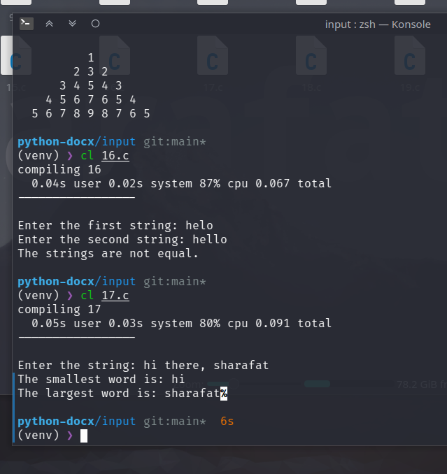

18 Write a C program to replace all the white spaces in a string with double white spaces.

// Write a C program to replace all the white spaces in a string with double white spaces.
#include <stdio.h>
int main()
{
char str[100];
printf("Enter the string: ");
scanf("%[^\n]%*c", str);
char white_space_doubled_str[200];
int i = 0, j = 0;
while (str[i] != '\0')
{
if (str[i] == ' ')
{
white_space_doubled_str[j] = ' ';
white_space_doubled_str[j+1] = ' ';
j += 2;
}
else
{
white_space_doubled_str[j] = str[i];
j++;
}
i++;
}
white_space_doubled_str[j] = '\0';
printf("The string with double white spaces is: %s\n", white_space_doubled_str);
return 0;
}
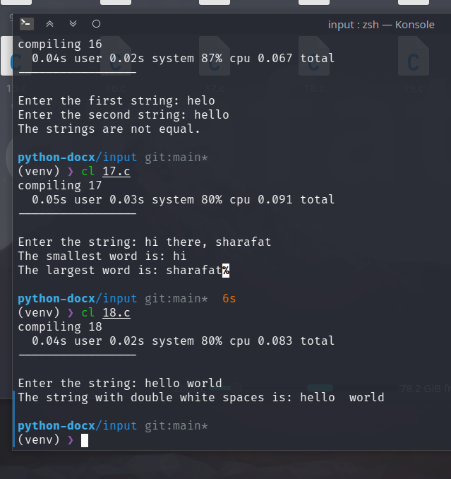

19 Write a C program to enter multiple strings and display them in lexicographical order.

// Write a C program to enter multiple strings and display them in lexicographical order.
#include <stdio.h>
#include <string.h>
int main()
{
int n;
printf("Enter the number of strings: ");
scanf("%d%*c", &n);
char str[n][100];
for (int i = 0; i < n; i++)
{
printf("Enter the string: ");
scanf("%[^\n]%*c", &str[i]);
}
for (int i = 0; i < n; i++)
{
for (int j = i+1; j < n; j++)
{
if (strcmp(str[i], str[j]) > 0)
{
char temp[100];
strcpy(temp, str[i]);
strcpy(str[i], str[j]);
strcpy(str[j], temp);
}
}
}
printf("The strings in lexicographical order are:\n");
for (int i = 0; i < n; i++)
{
printf("\t%s\n", str[i]);
}
}
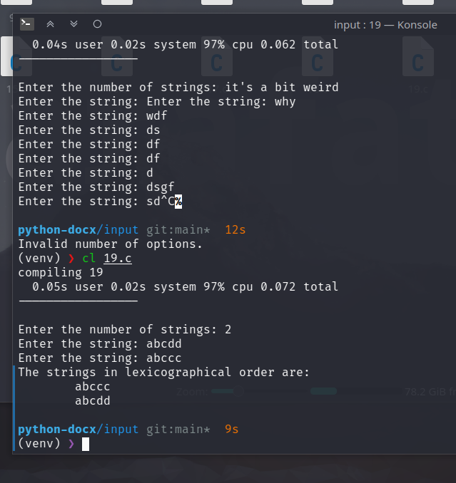

20 Write a C program to concatenate two strings without using any string function.

// Write a C program to concatenate two strings without using any string function.
#include <stdio.h>
int main()
{
char str1[100], str2[100];
printf("Enter the first string: ");
scanf("%[^\n]%*c", str1);
printf("Enter the second string: ");
scanf("%[^\n]%*c", str2);
int i = 0;
while (str1[i] != '\0')
{
i++;
}
int j = 0;
while (str2[j] != '\0')
{
str1[i] = str2[j];
i++;
j++;
}
str1[i] = '\0';
printf("The concatenated string is: %s\n", str1);
}
